- Log in to Microsoft 365
- Open Stream from the app launcher in M365. If Stream is not visible click all Apps and select it from there
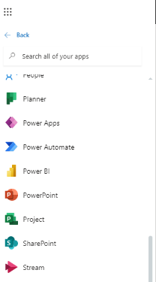
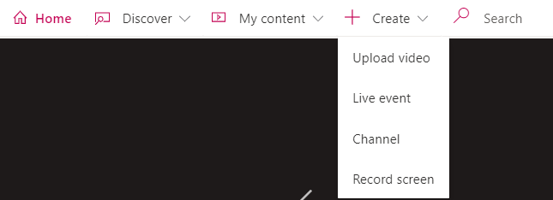
- In the Stream App in the top of the screen click +Create and choose Upload video
- In the screen that opens you can drag and drop any compatible video file or browse for them
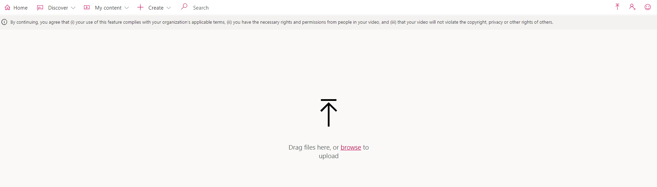
- Job done

